**Chapter 3: CONVERSIONS**

**Topic – 1: Ԑ-NFA To NFA**

**Conversion Chain**

**NFA with Ԑ 🡪 NFA without Ԑ 🡪 DFA**

**Ԑ-Closure**

* It means transition from **Ԑ**.
* A state with **Ԑ** can make transition to **itself** & all the states that are **linearly connected forward** to it.
* Meaning states which seem to be **derived** from it as per **drawn arrows**.

**Steps Involved (Hard Explanation)**

* **Step 1:** Find **Ԑ-closure** (**Ԑ\***) from each state, which can give **multiple outputs**.
* **Step 2:** Then pick up a **symbol** from **alphabet** & find transitions of obtained **output states** with a state from **previous step** with that symbol.
* **Step 3:** Then change the **state** & **repeat it** until all states are done.
* **Step 4:** Then pick up another **symbol** & do the same again with all states.

**Steps Involved (Straight Explanation)**

* For each symbol & their combination with each state, apply the formula given below.

**δ'(qi,si) = δ(δ(δ(qi, Ԑ),si),Ԑ)**

**Example**

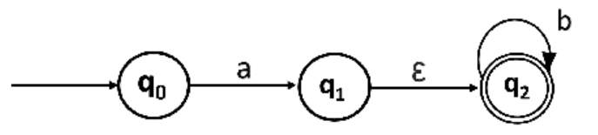

**Note!**

**🡪 On getting Ԑ symbol the q0 goes to q0, q1 & q2.**

**🡪 q1 goes to q1 & q2.**

**🡪 q2 goes to q2 itself.**

**δ'(q0,a)**

**= δ(δ(δ(q0, Ԑ),a),Ԑ)**

**= δ(δ(q0,a),Ԑ) AND δ(δ(q1,a),Ԑ) AND δ(δ(q2,a),Ԑ)**

**= δ(q1, Ԑ) AND δ(φ,Ԑ) AND δ(φ,Ԑ)**

**= q0,q1 AND φ AND φ**

**= {q0,q1}**

**Similarly, we get:**

**δ'(q0,b) = δ(δ(δ(q0, Ԑ),b),Ԑ) = φ**

**δ'(q1,a) = φ**

**δ'(q1,b) = {q2}**

**δ'(q2,a) = φ**

**δ'(q2,b) = {q2}**

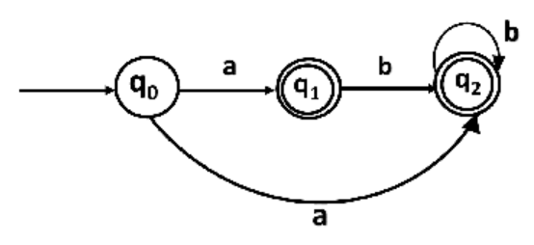

**Topic – 2: NFA To DFA**

**Steps Involved**

* **Step 1:** From the given **NFA** diagram, look at the states which are transitioning to **multiple states** from **same input**.
* **Step 2:** **Remove** all the **common** input transition lines.
* **Step 3:** Make **separate states** for receiving common transitions.
* **Step 4:** Keep those states’ name as **set of states** they were transitioning to.
* **Step 5:** Put uncommon transitions toward the **newly created states**.
* **Step 6:** Make **square brackets** around state symbols.
* **Step 7:** Give **proper names** to all the states now.
* **Step 8 (optional):** **Eliminate** all the **unreachable** states.

**Example**

**NFA:**

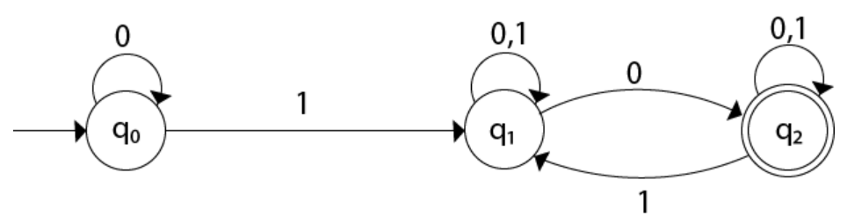

**DFA:**

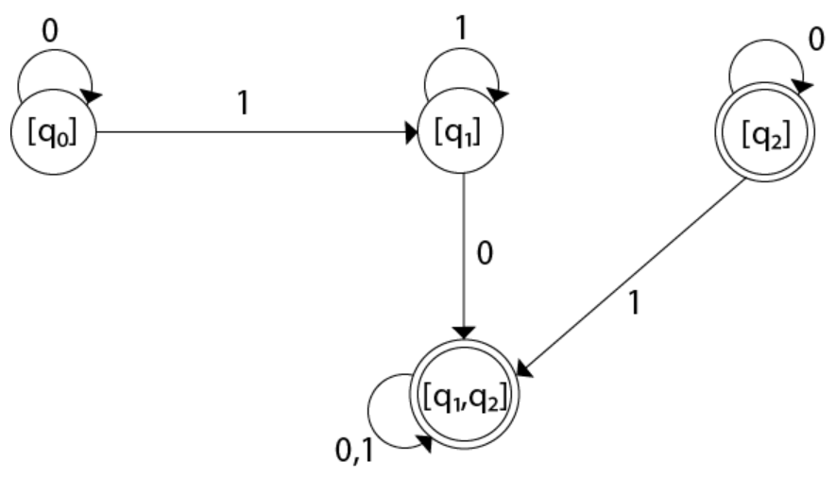

**[q2] can be safely removed as it is unreachable.**

**Example 2**

**NFA:**

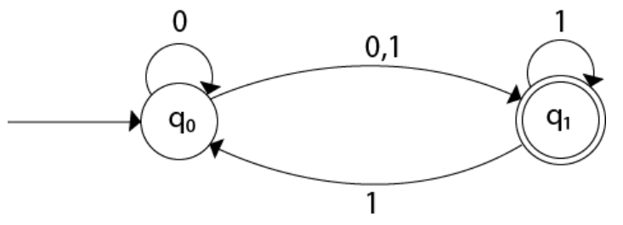

**DFA:**

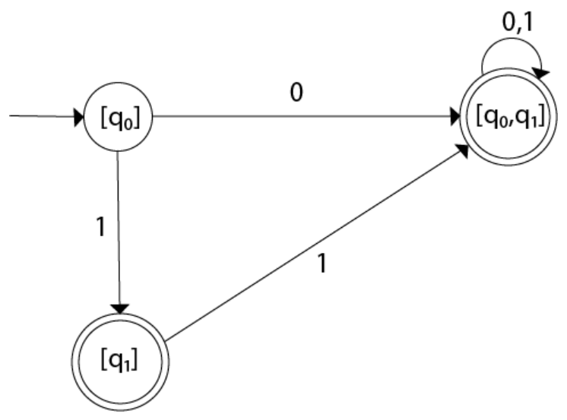

**These states can now be named as A, B, C etc.**

**Topic – 3: Ԑ-NFA To DFA**

**Steps Involved**

* **Step 1:** We find each simultaneous **δ'(qi, si)** as per a **linear flow**.
* **Step 2:** Then we make **union** of each **simultaneous transition** as a **unit** with the **input symbol**.
* **Step 3:** We name the transitions as per that.

**Example**

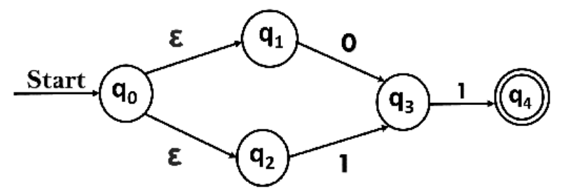

**δ'(A, 0)**

**= Ԑ -closure {δ((q0, q1, q2), 0)}**

**= Ԑ-closure {δ(q0, 0) ∪ δ(q1, 0) ∪ δ(q2, 0)}**

**= Ԑ-closure {q3}**

**= {q3}**

**δ'(A, 1)**

**= ε-closure {δ((q0, q1, q2), 1)}**

**= ε-closure {δ((q0, 1) ∪ δ(q2, 1) ∪ δ(q2, 1)}**

**= ε-closure {q3}**

**= {q3}**

**= B**

**δ'(B, 0)**

**= ε-closure {δ(q3, 0)}**

**= ϕ**

**δ'(B, 1)**

**= ε-closure {δ(q3, 1) }**

**= ε-closure {q4}**

**= {q4}**

**= C**

**δ'(C, 0)**

**= ε-closure {δ(q4, 0) }**

**= ϕ**

**δ'(C, 1)**

**= ε-closure {δ(q4, 1) }**

**= ϕ**

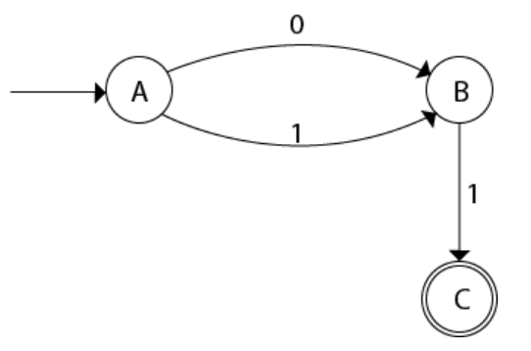

**Example 2**

**Ԑ-NFA:**

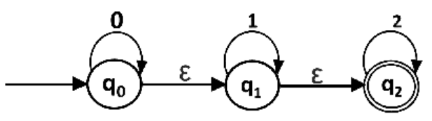

**Partial DFA:**

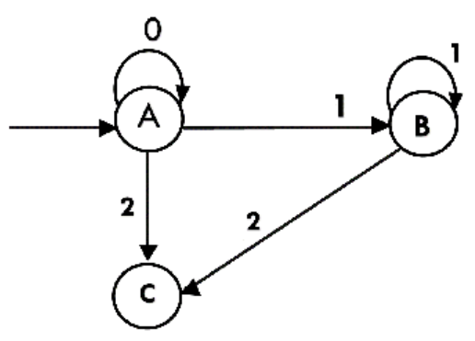

**A = {q0, q1, q2}**

**B = {q1, q2}**

**C = {q2}**

**Final DFA:**

